ABSTRACT TITLE:The Common Pathways of Neutrophils, Macrophages, Eosinophils and all of the Other Wonderful Cell Types in Our Community
AUTHORS:James Bond1, Harry Potter2
AFFILIATIONS:1. Fleming Institute of Research 2. Hogwarts Medical Center
ABSTRACT BODY:The Society for Leukocyte Biology is a community of 1200+ like-minded researchers and clinicians. Emphasizing supporting members, SLB provides opportunities to present and publish at conferences and through the well-regarded Journal of Leukocyte Biology. Volunteer led committees provide leadership opportunities for all education and career levels; workshops and training programs provide valuable professional development training; and an extensive award program offers recognition for members at all stages. Additional support is provided to members via travel grants with a special focus on equitable outreach around the globe. Join SLB for the benefit of a small community with quality science.
IMAGE (optional):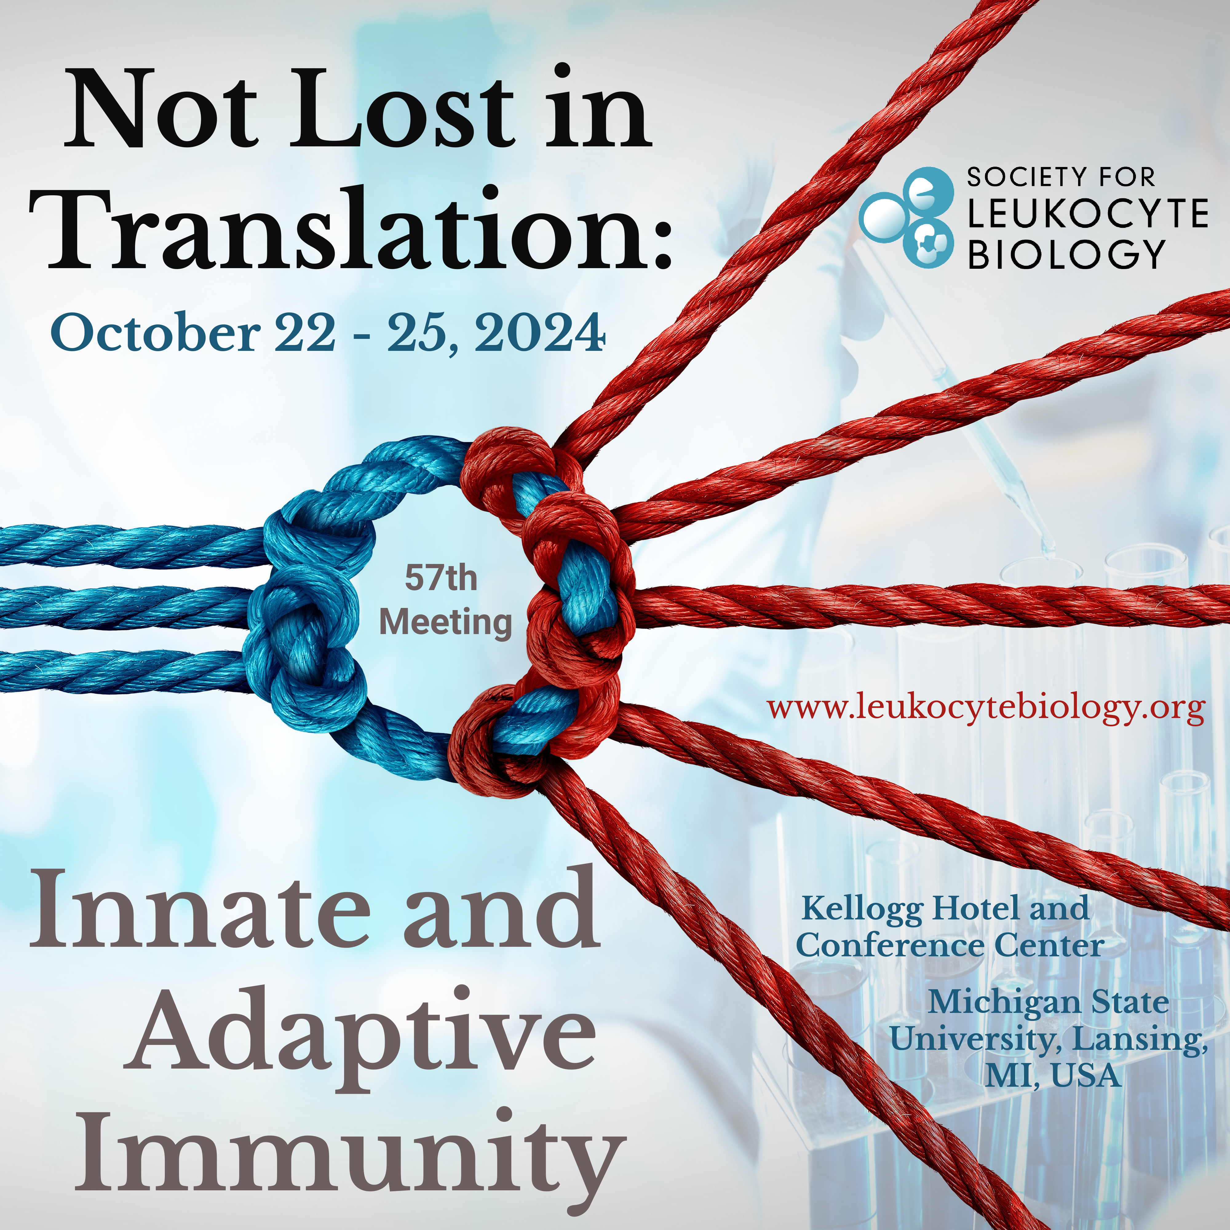
IMAGE CAPTION (optional):This is the SLB 2024 block ad
FUNDING SOURCE (optional):None

